**A Secure Data Dynamics and Public Auditing Scheme for Cloud Storage**

**OBJECTIVE:**

This paper desire to suggest a secure public auditing scheme applying third party auditors to authenticate the privacy, reliability, and integrity of data stored in the cloud. This proposed auditing scheme composes the use of the **AES-256 algorithm**. And perform data dynamics operation which deals with mostly insertion, deletion, and, modification.

**DEVELOPMENT PROCEDURE:**

Initially analyzing the base paper

In base paper, the we have to find out security, verification and Integrity

It shows the need of **AES-256 algorithm** for encryption, **SHA-512** for integrity check and **RSA-15360** for public key encryption

**EXECUTION PROCEDURE:**

* **Need requirements**
  + **Internet connection**
  + **Eclipse IDE**
  + **Sqlyog (MySQL)**
* **Run 🡪Run As Server 🡪select tomcat server 🡪 Copy run URL 🡪 Paste at any browser 🡪 Then follow below screen shots**

**REFERENCE LINK:**

* <https://www.sciencedirect.com/science/article/pii/S153204641830056X>

**OUTPUT SCREEN SHOTS:**

Home Page:

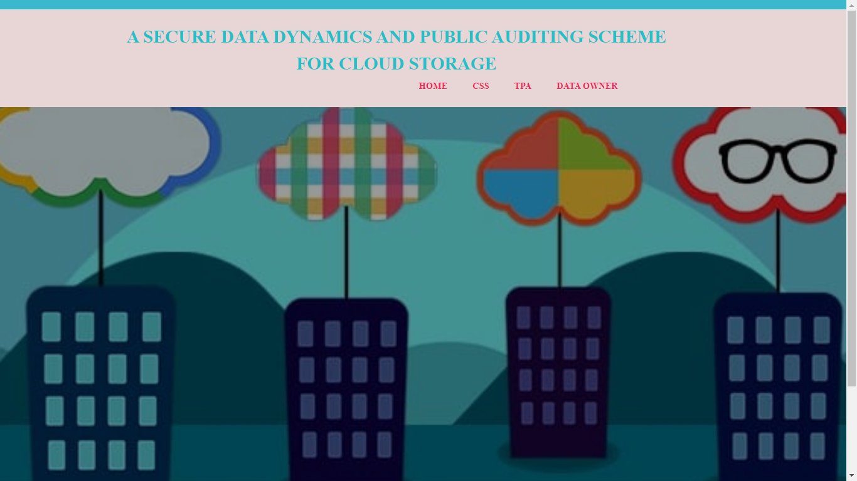

Css Login

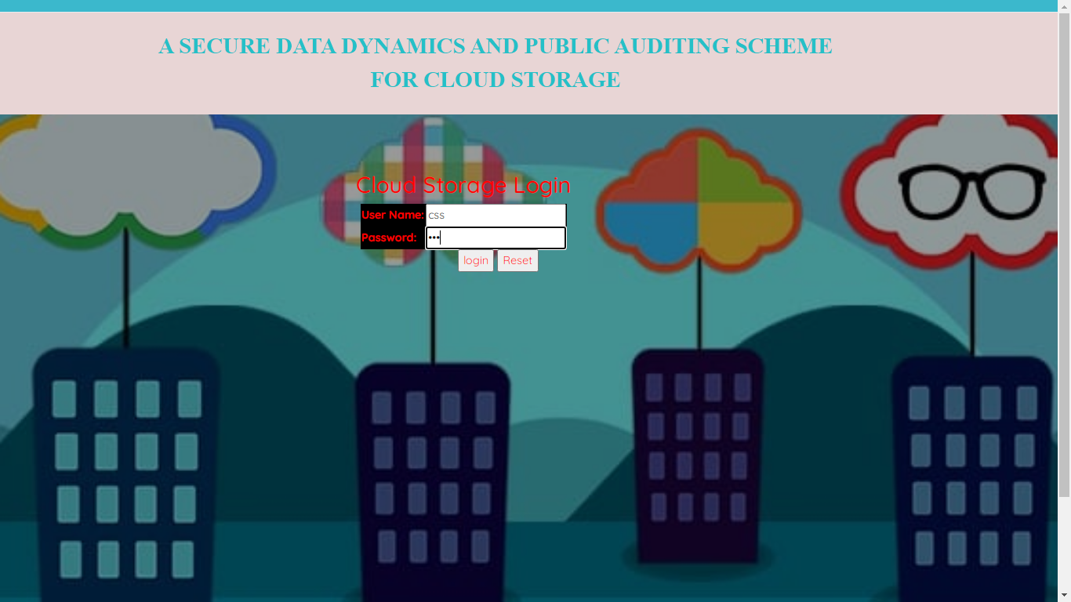

CSS home page:

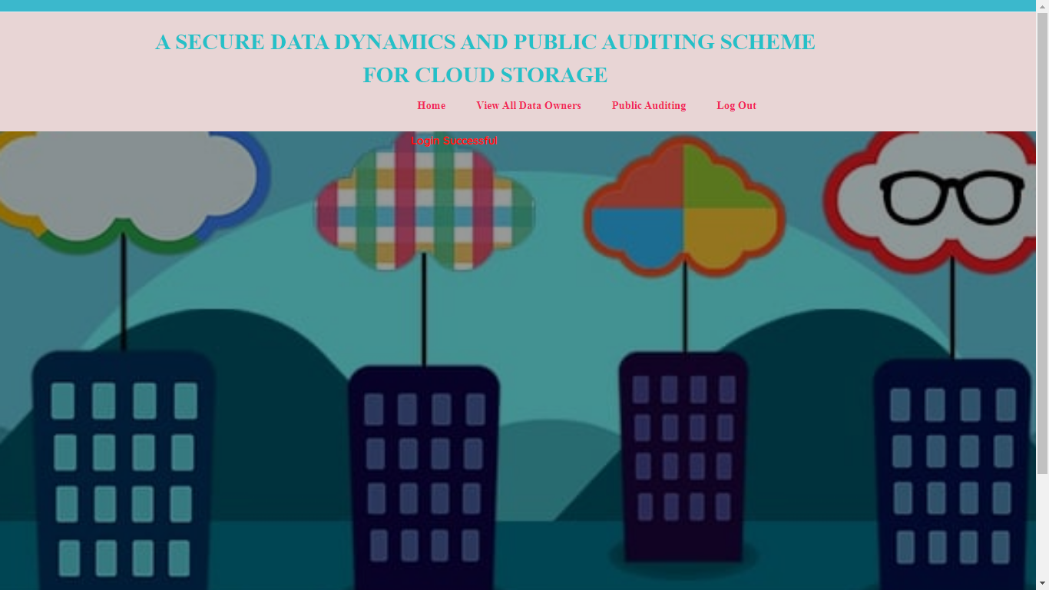

View all data owners:

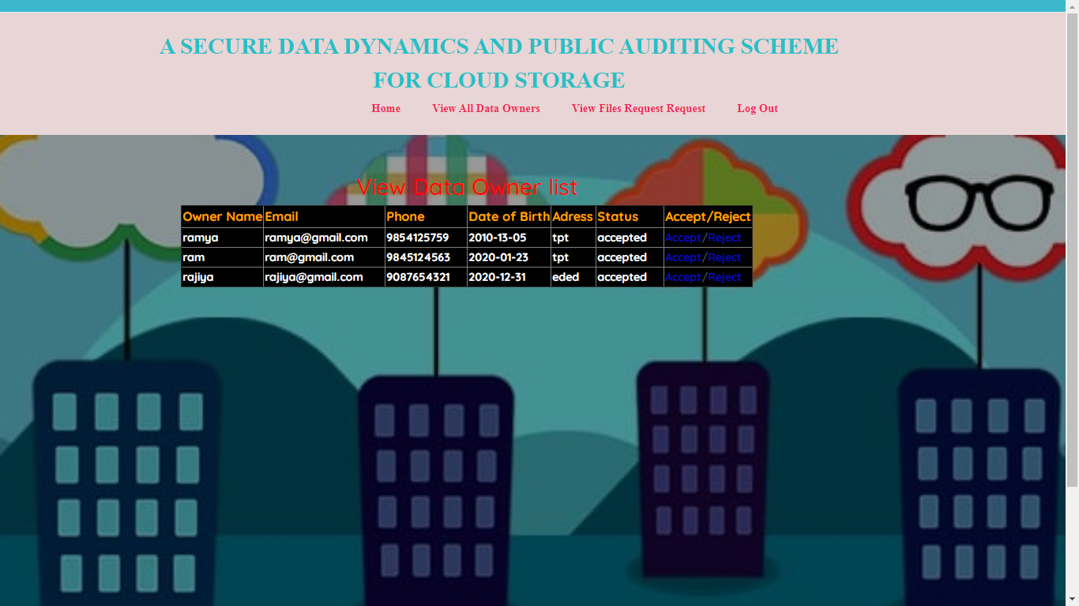

Public auditing:

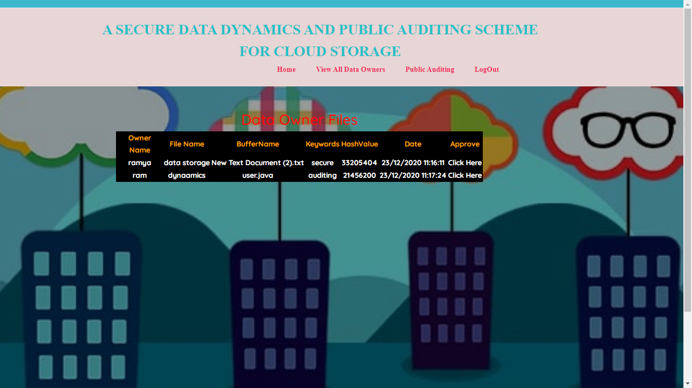

Tpa login page:

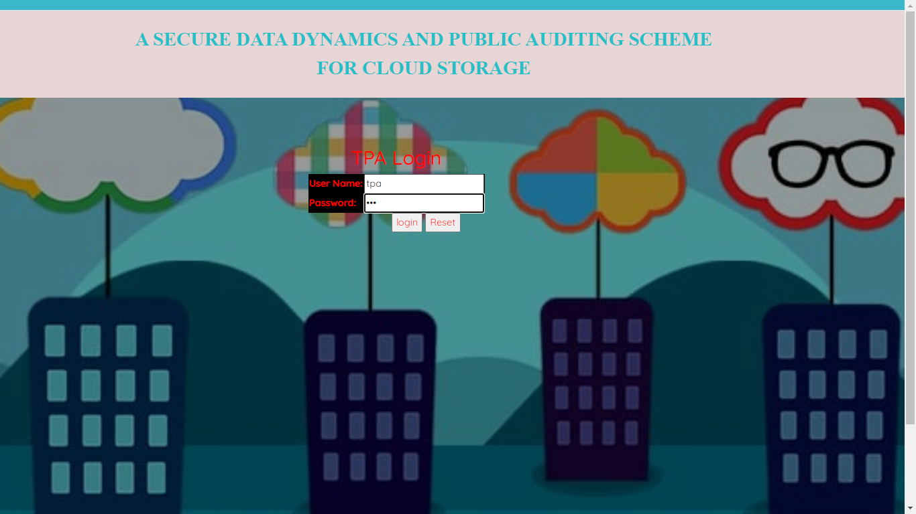

Tpa home page:

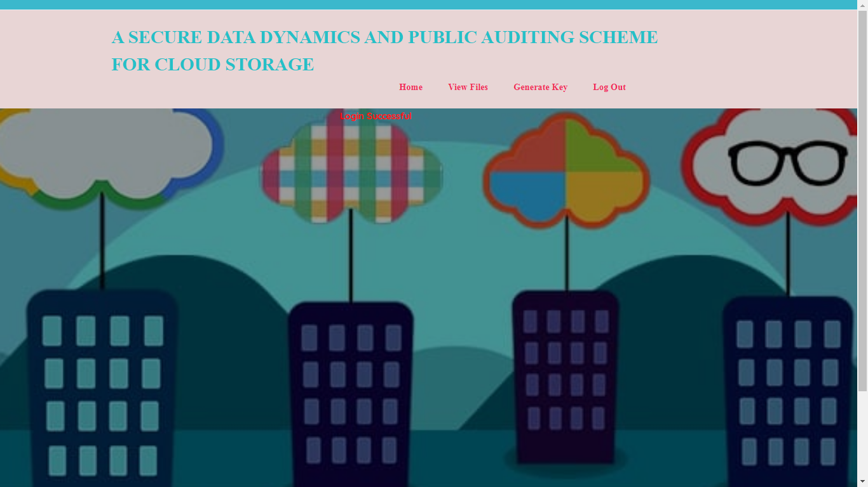

View files:

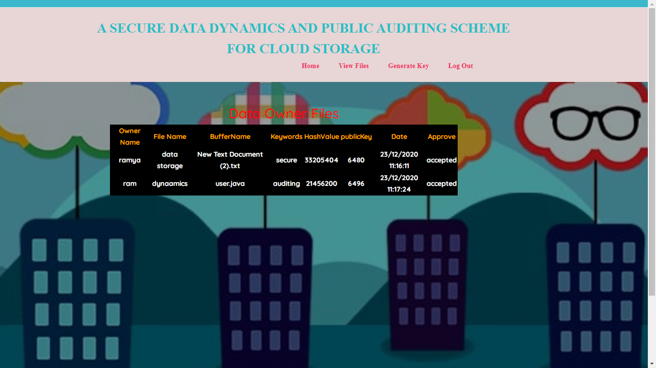

Generate Key:

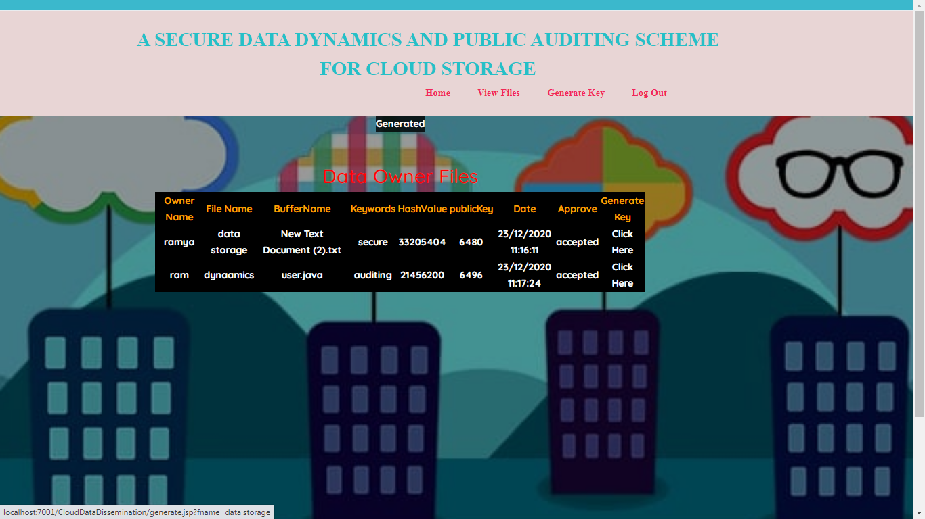

Data owner login page

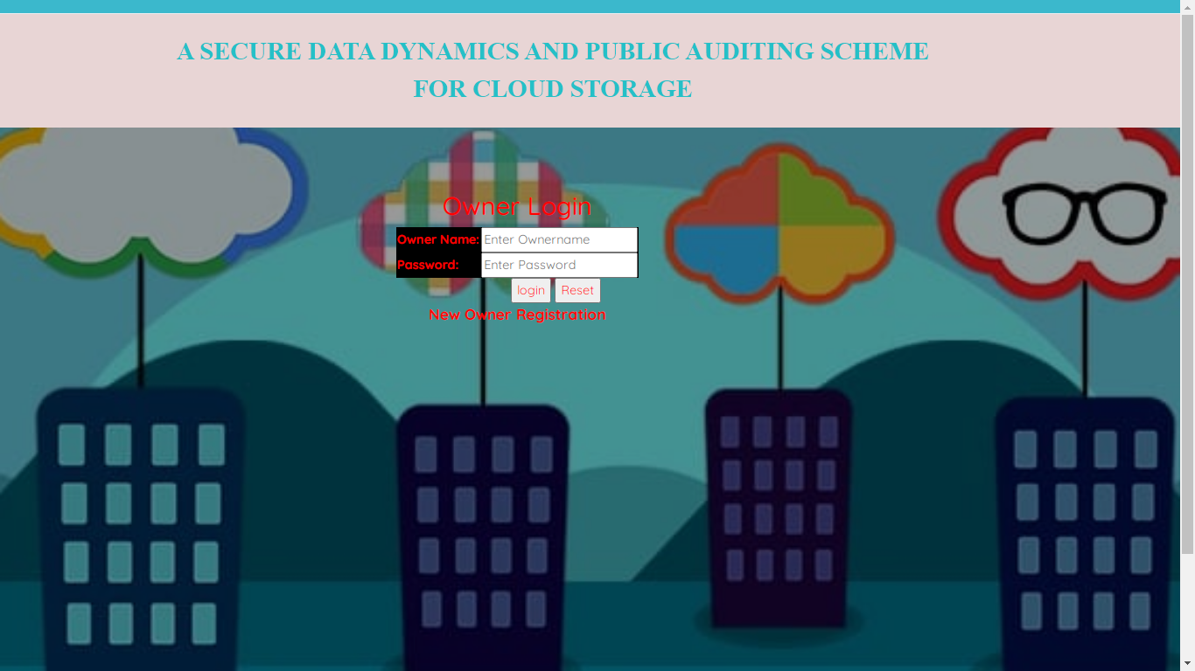

Registration page

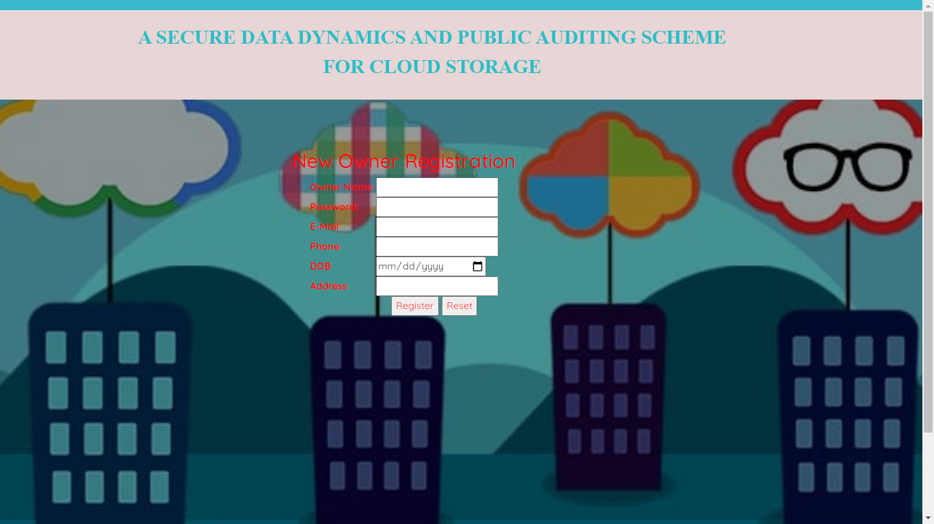

Owner home page:

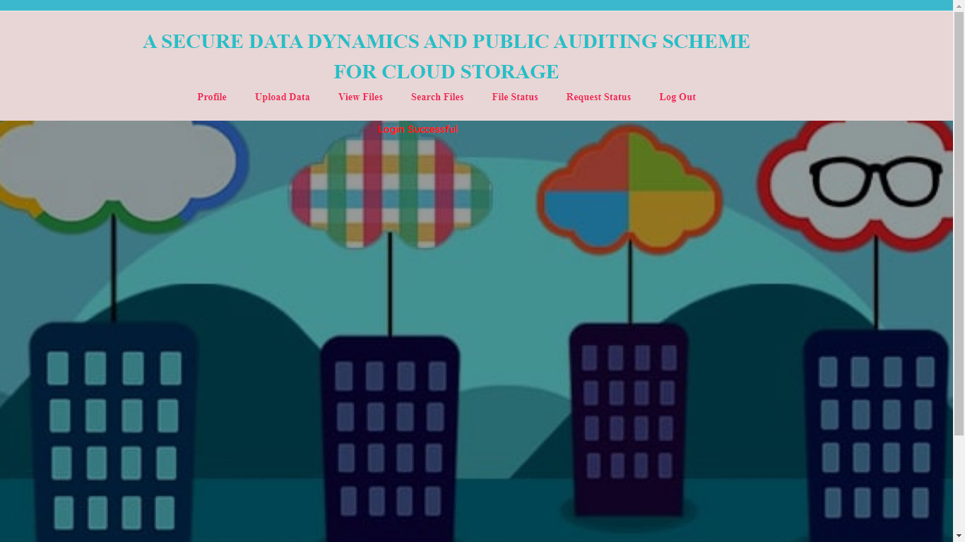

Upload data:

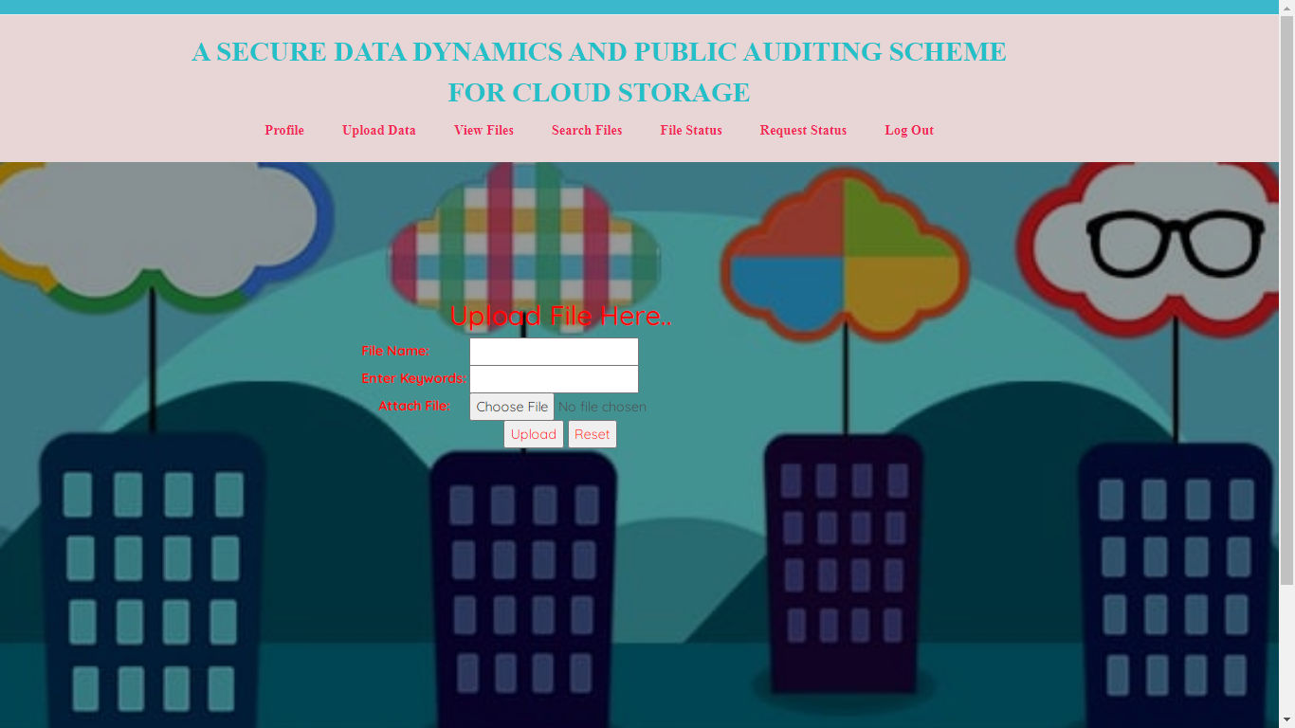

View files:



Search files:

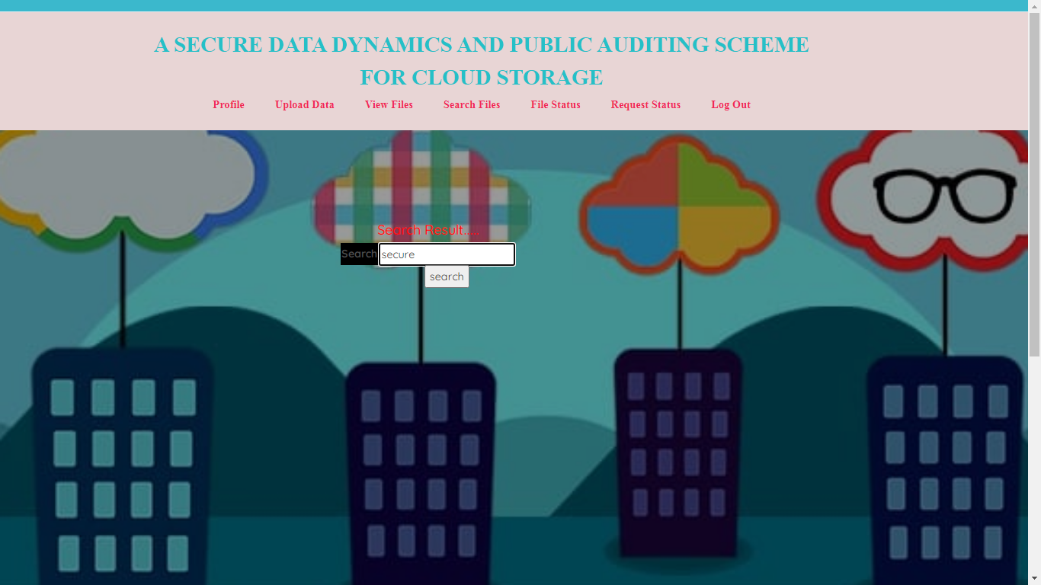

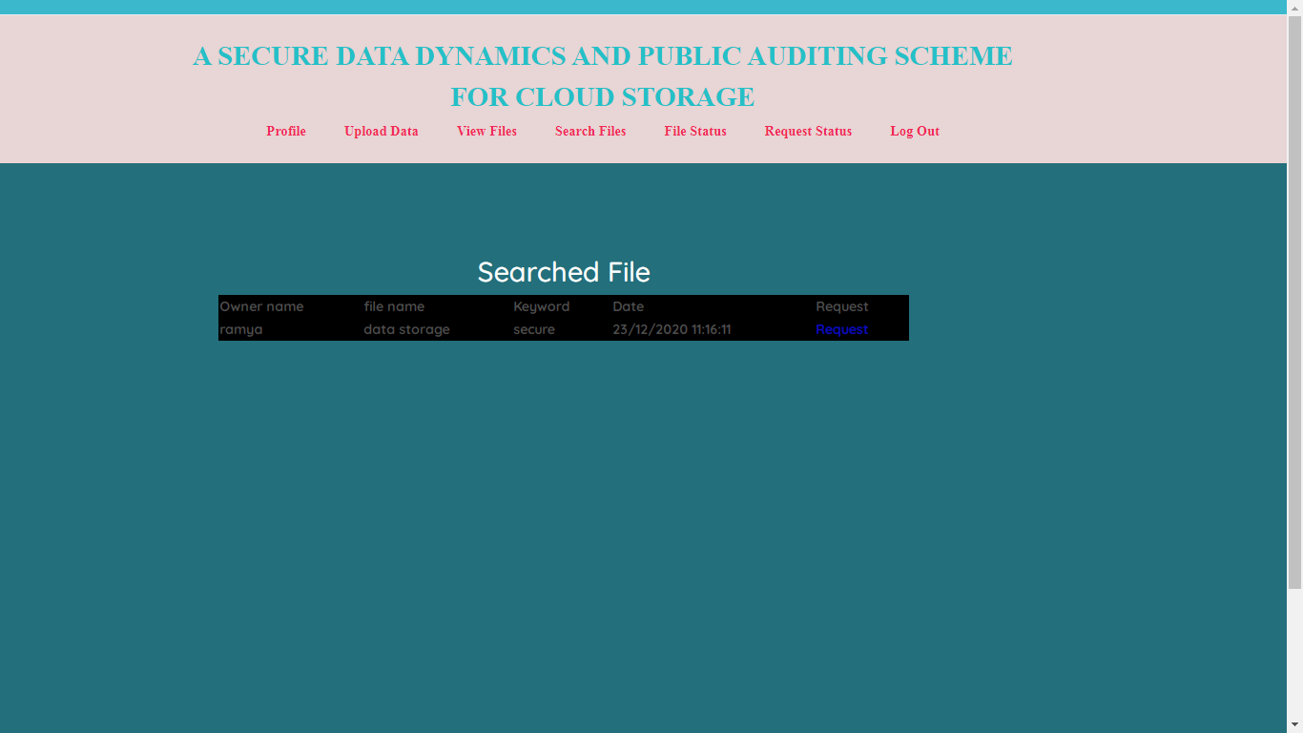

File status:

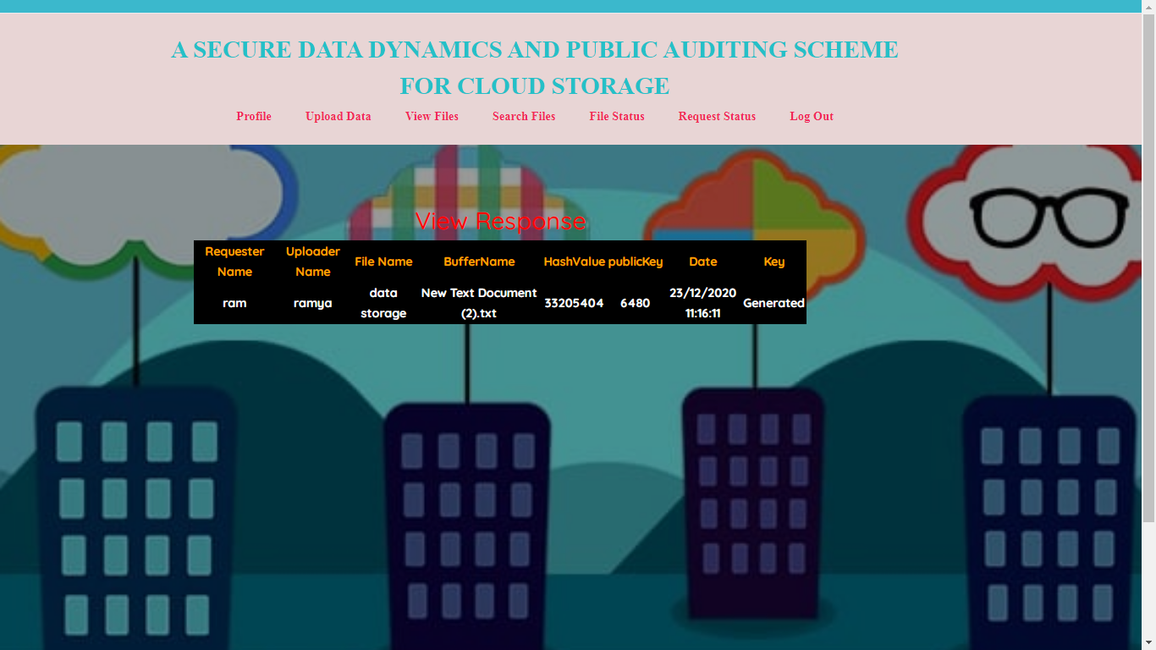

Request status:

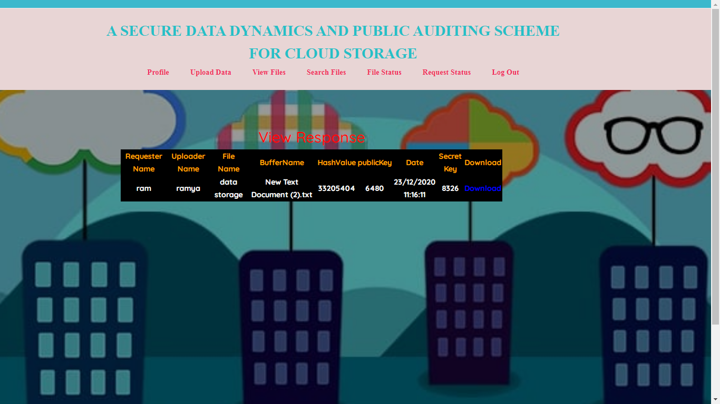

Download:

